**Weekly Status Report – 2018-June-19**

|  |  |
| --- | --- |
| **Project Name** | MLIK |
| **Team Lead** | Jacob Warnes |

|  |  |  |  |  |
| --- | --- | --- | --- | --- |
| **Roles** |  |  |  |  |
| **Week** | **Ashleigh Logan** | **Brendon Waters** | **Isaac Thiessen** | **Jacob Warnes** |
| 01 | Team Lead, Technical Writer, Database/Back-End | Front-End Developer, Technical Writer, Database/Back-End Developer | Technical Writer, Database/Back-End Developer | Technical Writer, Database/Back-End Developer |
| 02 | Front End Developer, Technical Writer | Team Lead, Technical Writer | Backend – Database, Technical Writer | Middleware – PHP, Technical Writer |
| 03 | Front-End/Middleware | Technical Writing | Middleware - PHP, Team Lead | Middleware |
| 04 |  |  |  |  |
| 05 | Middleware –PHP, Front-End | Front-End, Technical writer | Middleware – PHP, Database/Back-End | Team Lead , Technical writer |
| 06 | Middleware-PHP, Front-End | Front-end, Middleware -PHP | Middleware –PHP, Front-end | Team Lead, Middleware-PHP |
| 07 |  |  |  |  |
| 08 |  |  |  |  |

|  |
| --- |
| **Weekly Project Summary** |
| Status report completed. Purchase works and generates an html receipt |

|  |  |  |  |  |  |
| --- | --- | --- | --- | --- | --- |
| **Key Milestones Status** | | | | | |
| **ID** | **Description** | **Planned Completion** | **Forecasted**  **Completion** | **Actual Completion** | **Status** |
|  | Demo and Deliverables Week 1 Completed | *2018-05-15* | *2018-05-15* | *2018-05-15* | *Complete* |
|  | Demo and Deliverables Week 2 Completed | 2018-05-22 | 2018-05-22 | 2018-05-22 | Complete |
|  | Demo and Deliverables Week 3 Completed | 2018-05-29 | 2018-05-29 | 2018-05-29 | Complete |
|  | Demo and Deliverables Week 4 Completed | 2018-06-05 | 2018-06-05 | 2018-06-05 | Complete |
|  | Demo and Deliverables Week 5 Completed | 2018-06-11 | 2018-06-11 | 2018-06-11 | Complete |
|  | Demo and Deliverables Week 6 Completed | 2018-06-18 | 2018-06-18 | 2018-06-19 | Complete |
|  | Demo and Deliverables Week 7 Completed | 2018-06-22 | 2018-06-22 |  | Incomplete |

|  |  |  |  |  |  |
| --- | --- | --- | --- | --- | --- |
|  | Final Presentation | 2018-06-22 | 2018-06-22 |  | Incomplete |
|  | Final Report | 2018-06-22 | 2018-06-22 |  | Incomplete |

|  |
| --- |
| **Key Accomplishments for the Week** |
| Week 6 completed |

|  |  |  |  |
| --- | --- | --- | --- |
| **Task Assignments for the Coming Week** | | |  |
| **ID** | **Description** | **Assigned To** | **On Schedule** |
| 84 | Consistent look and feel | Brendon ,Ashleigh, Isaac ,Jacob | Yes |
| 78-82 | Team lead activities | Ashleigh | Yes |
| 85 | Peer review | Brendon, Ashleigh ,Isaac, Jacob | Yes |
| 86 | Final report | Brendon, Ashleigh ,Isaac, Jacob | Yes |
|  |  |  |  |
|  |  |  |  |
|  |  |  |  |

|  |  |  |
| --- | --- | --- |
| **Tasks Completed in the Previous Week** | |  |
| **ID** | **Description** | **Assigned To** |
| 67-72 | Weekly leader tasks | Jacob |
| 74 | Payment process | Brendon |
| 75 | Confirmation email | Isaac |
| 76 | Order history | Isaac |
|  |  |  |
|  |  |  |
|  |  |  |

|  |  |
| --- | --- |
| Issues and Risks |  |
| **Description** | **Impact**  **(L,M,H)** |
| Final presentation | L |
|  |  |
|  |  |

|  |
| --- |
| **Gantt Chart** |

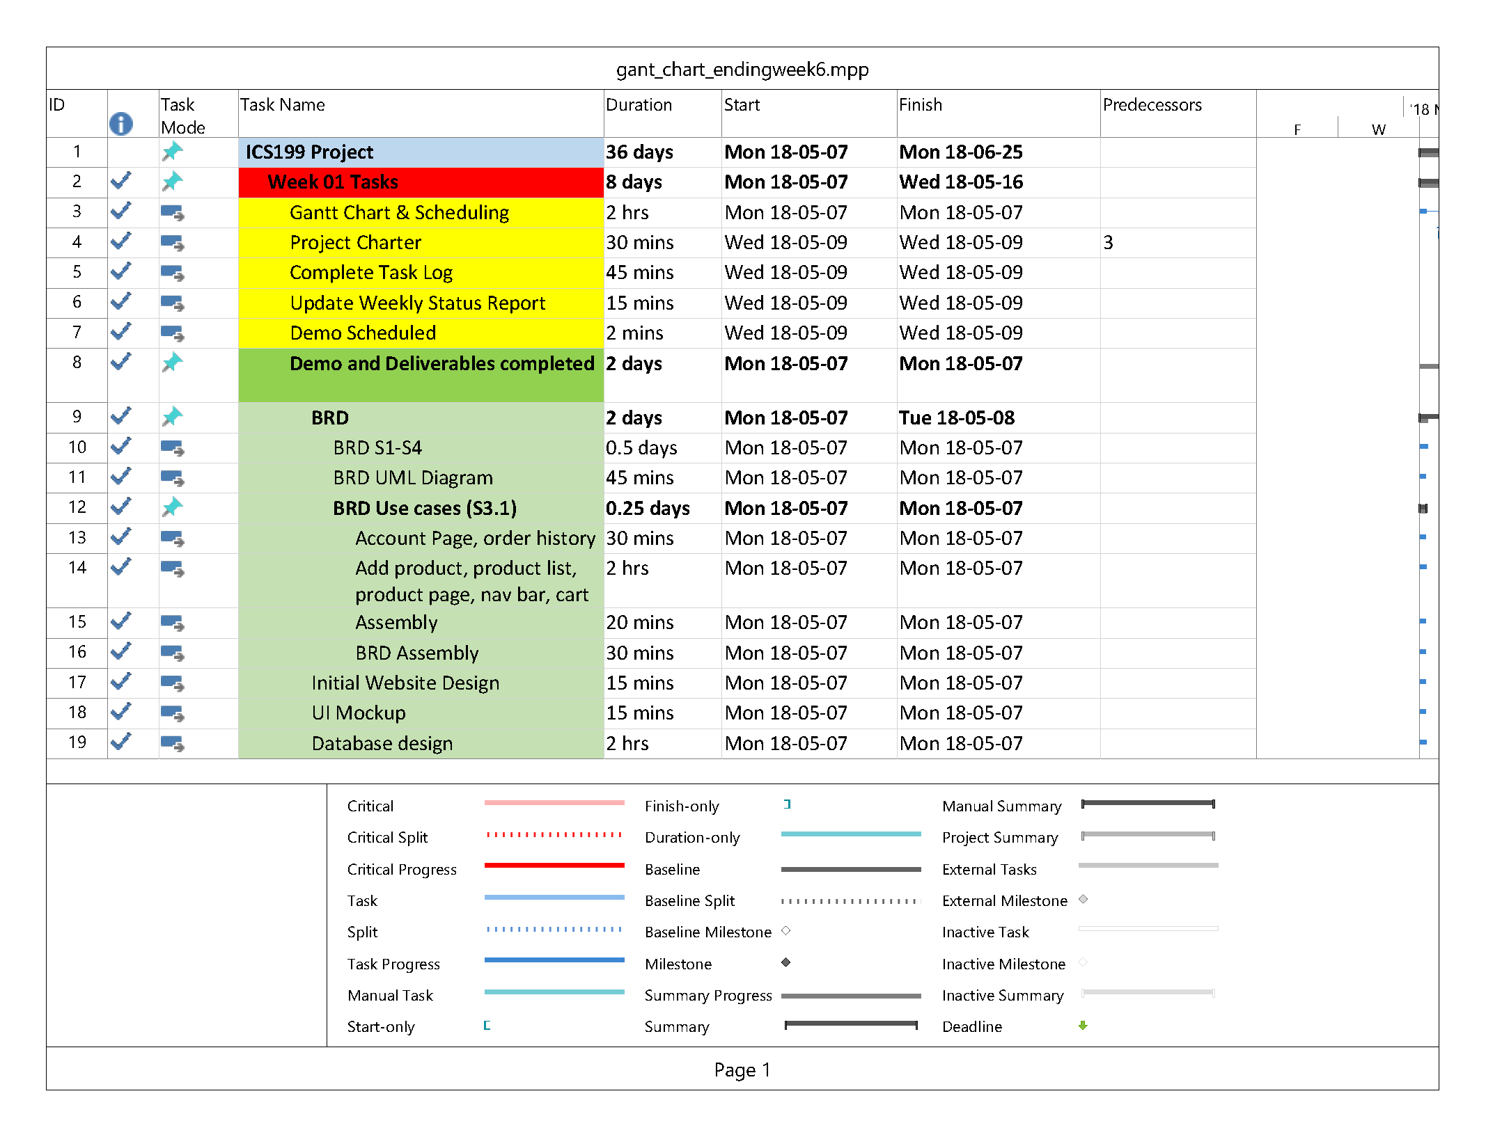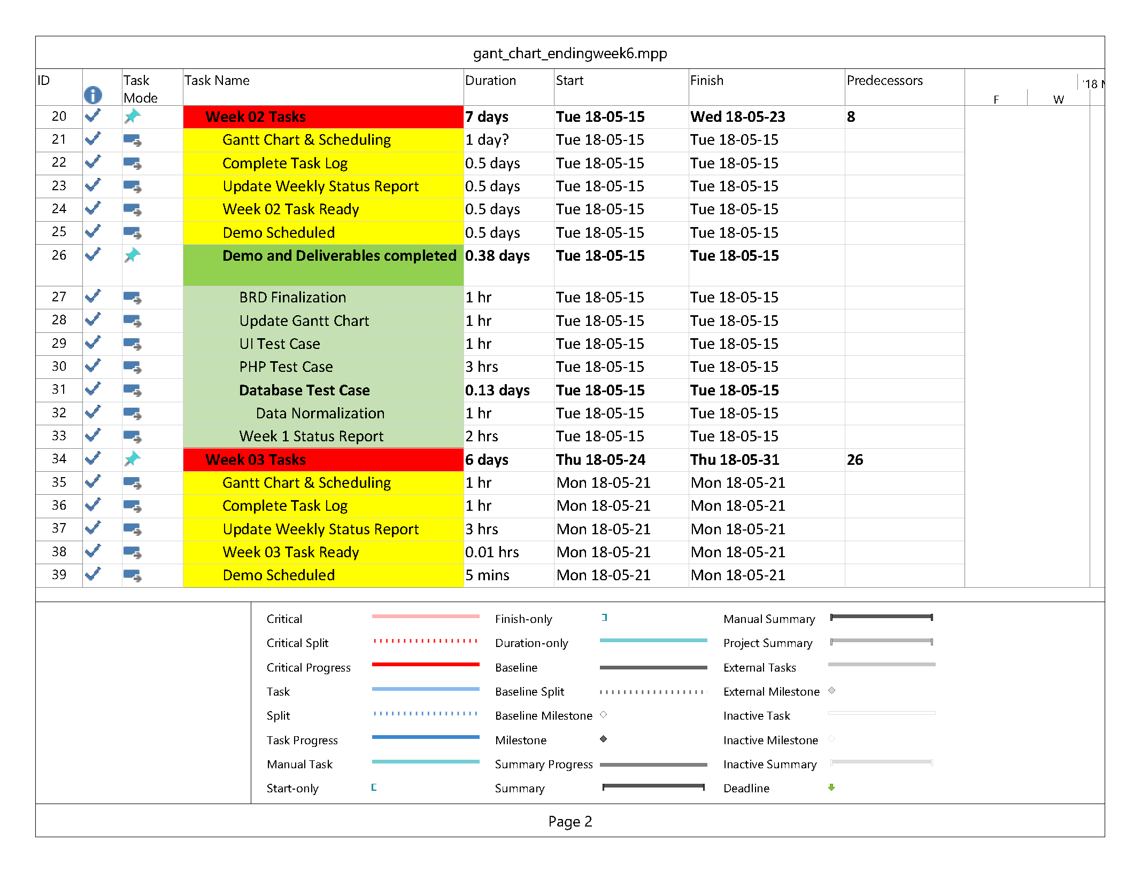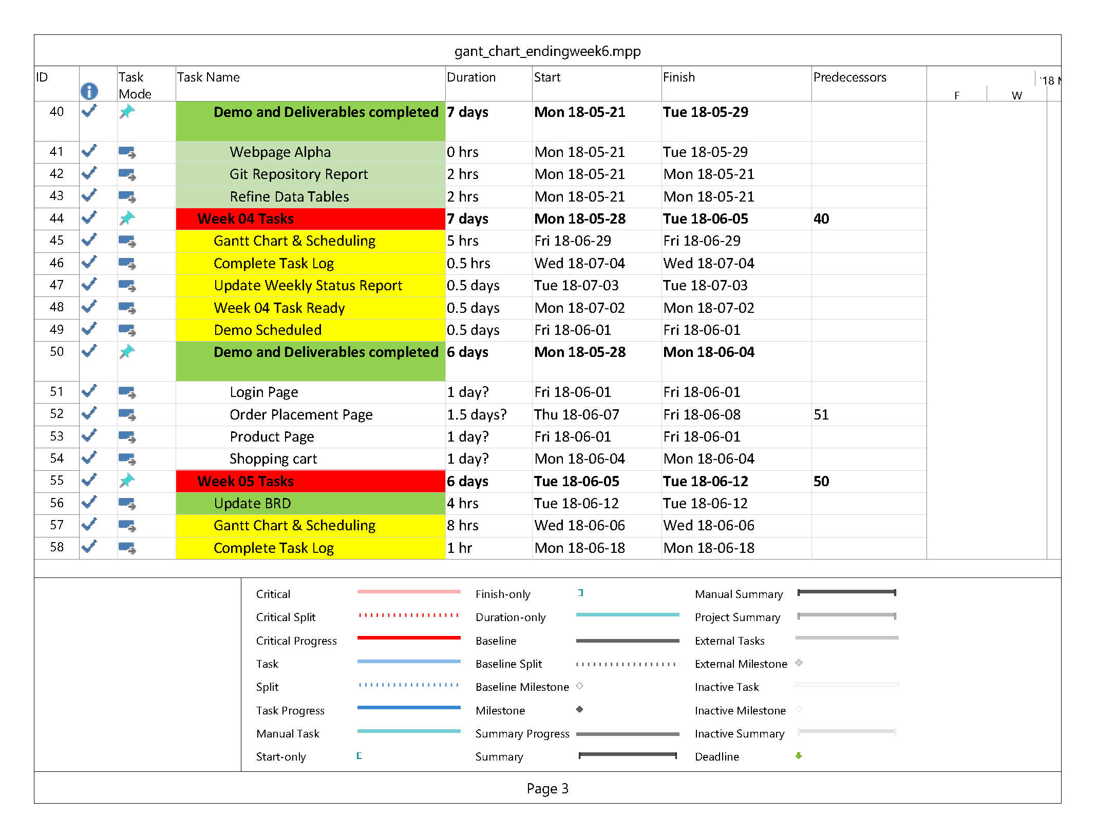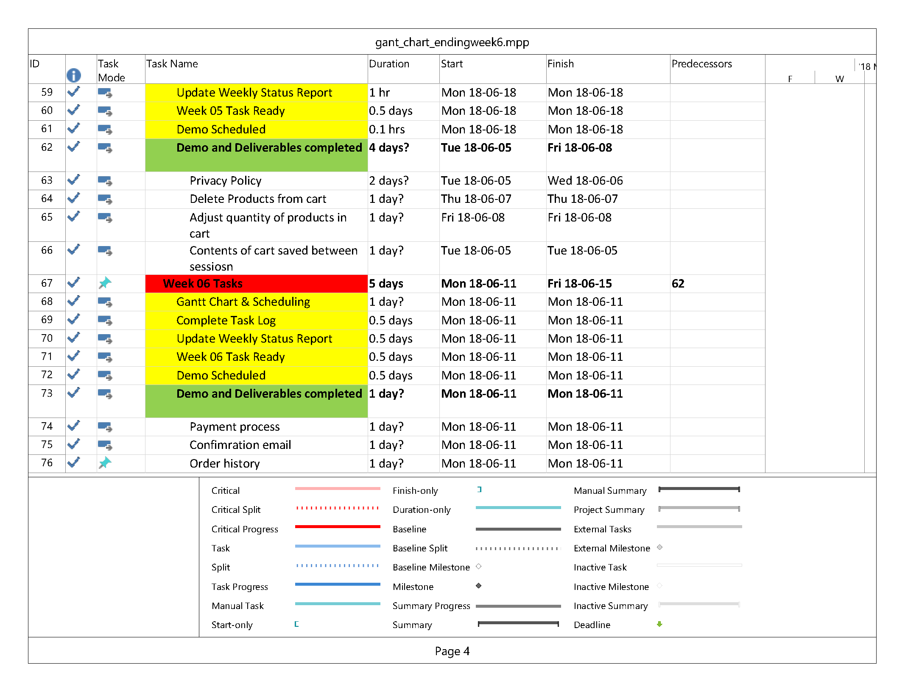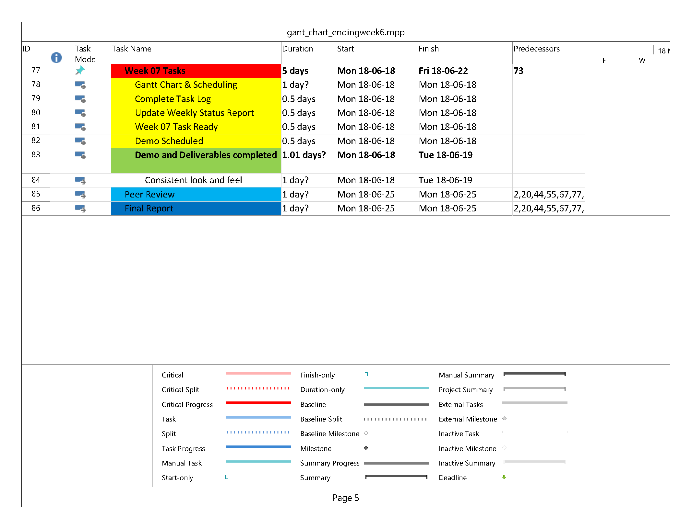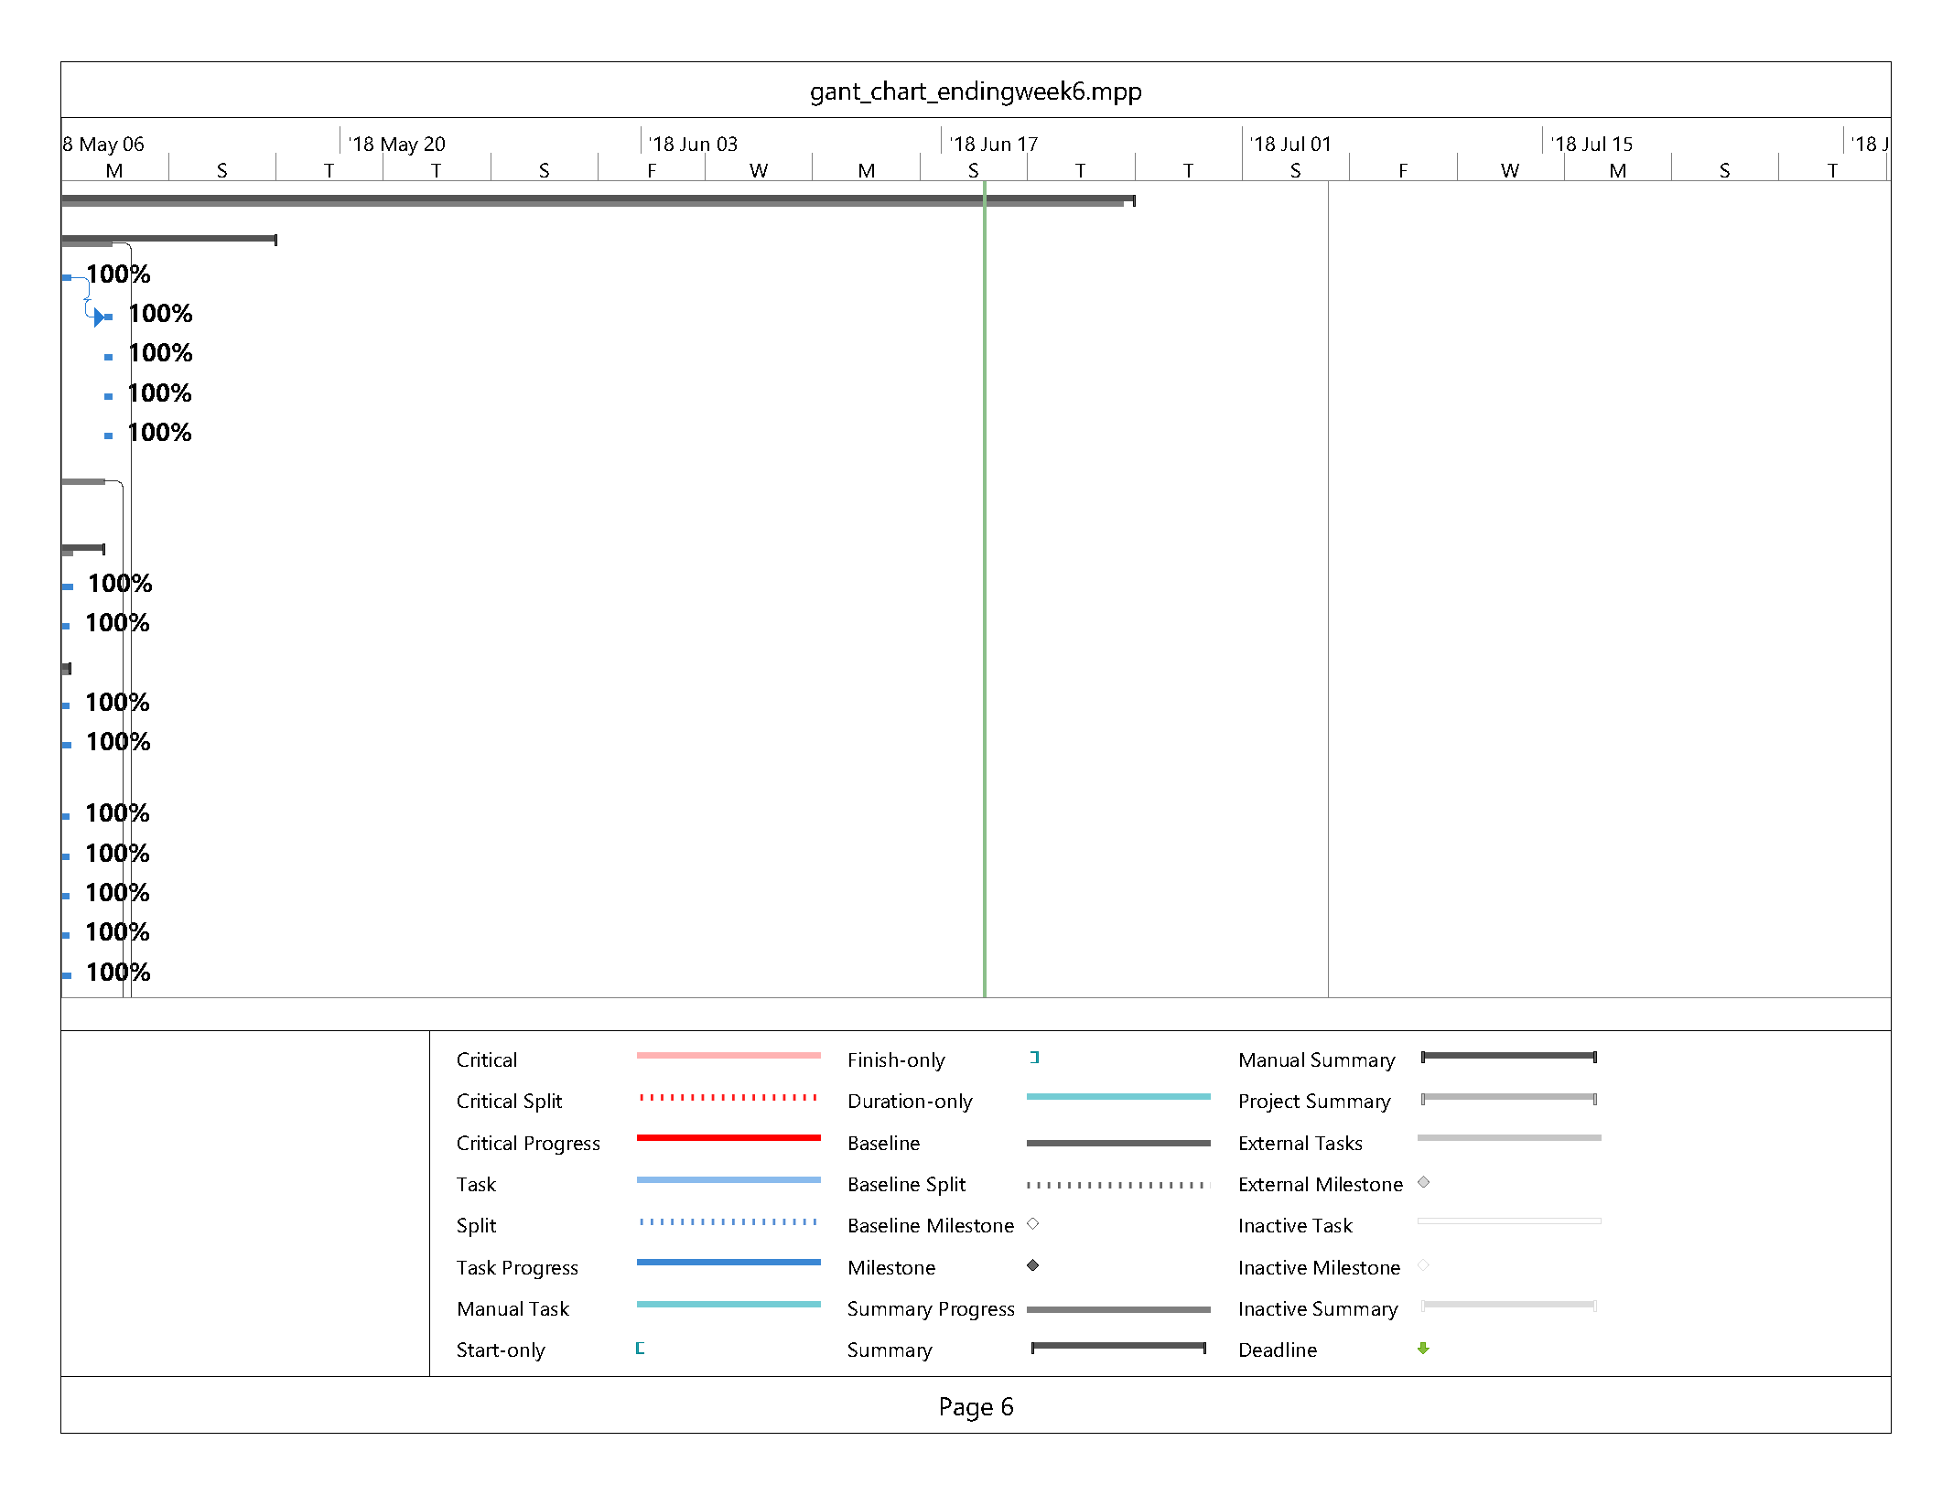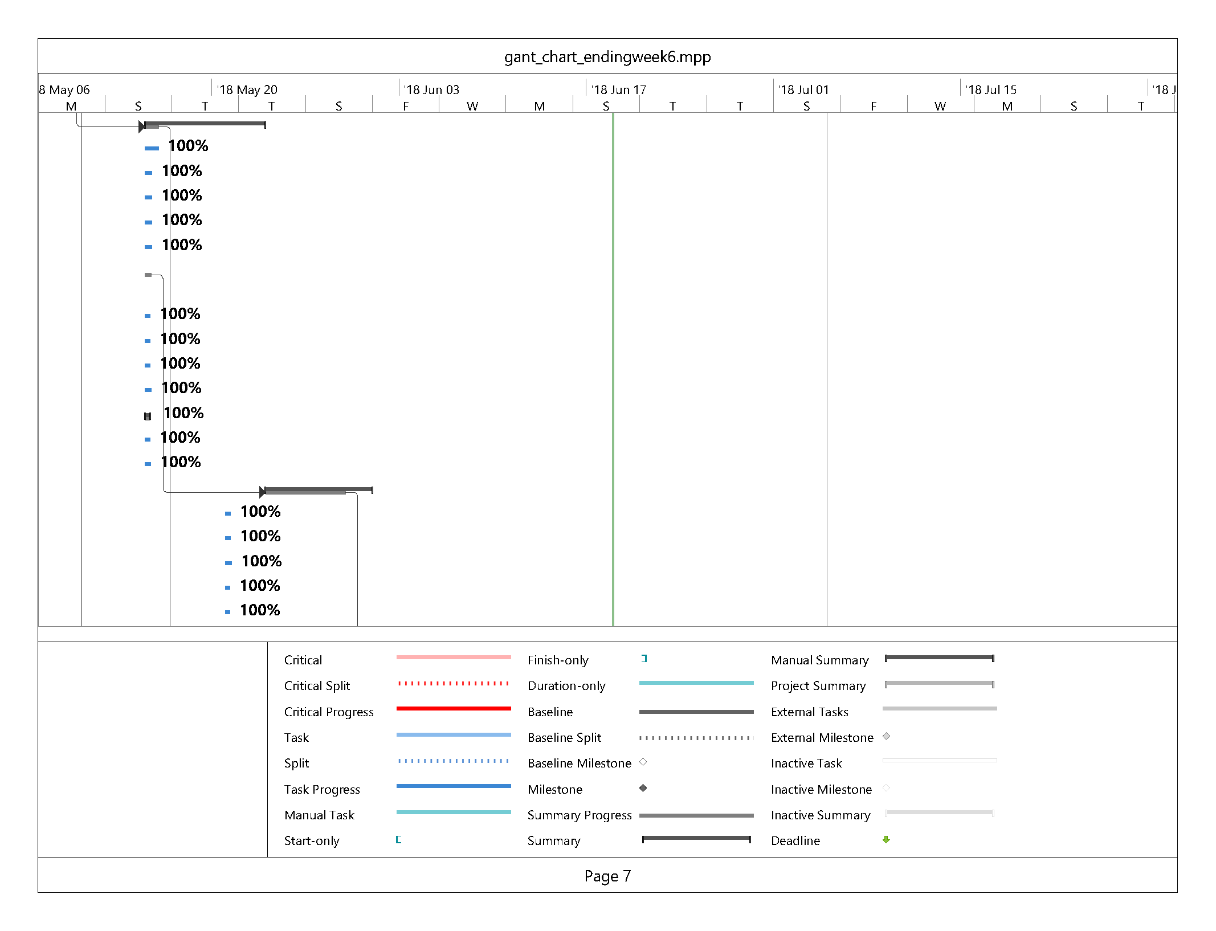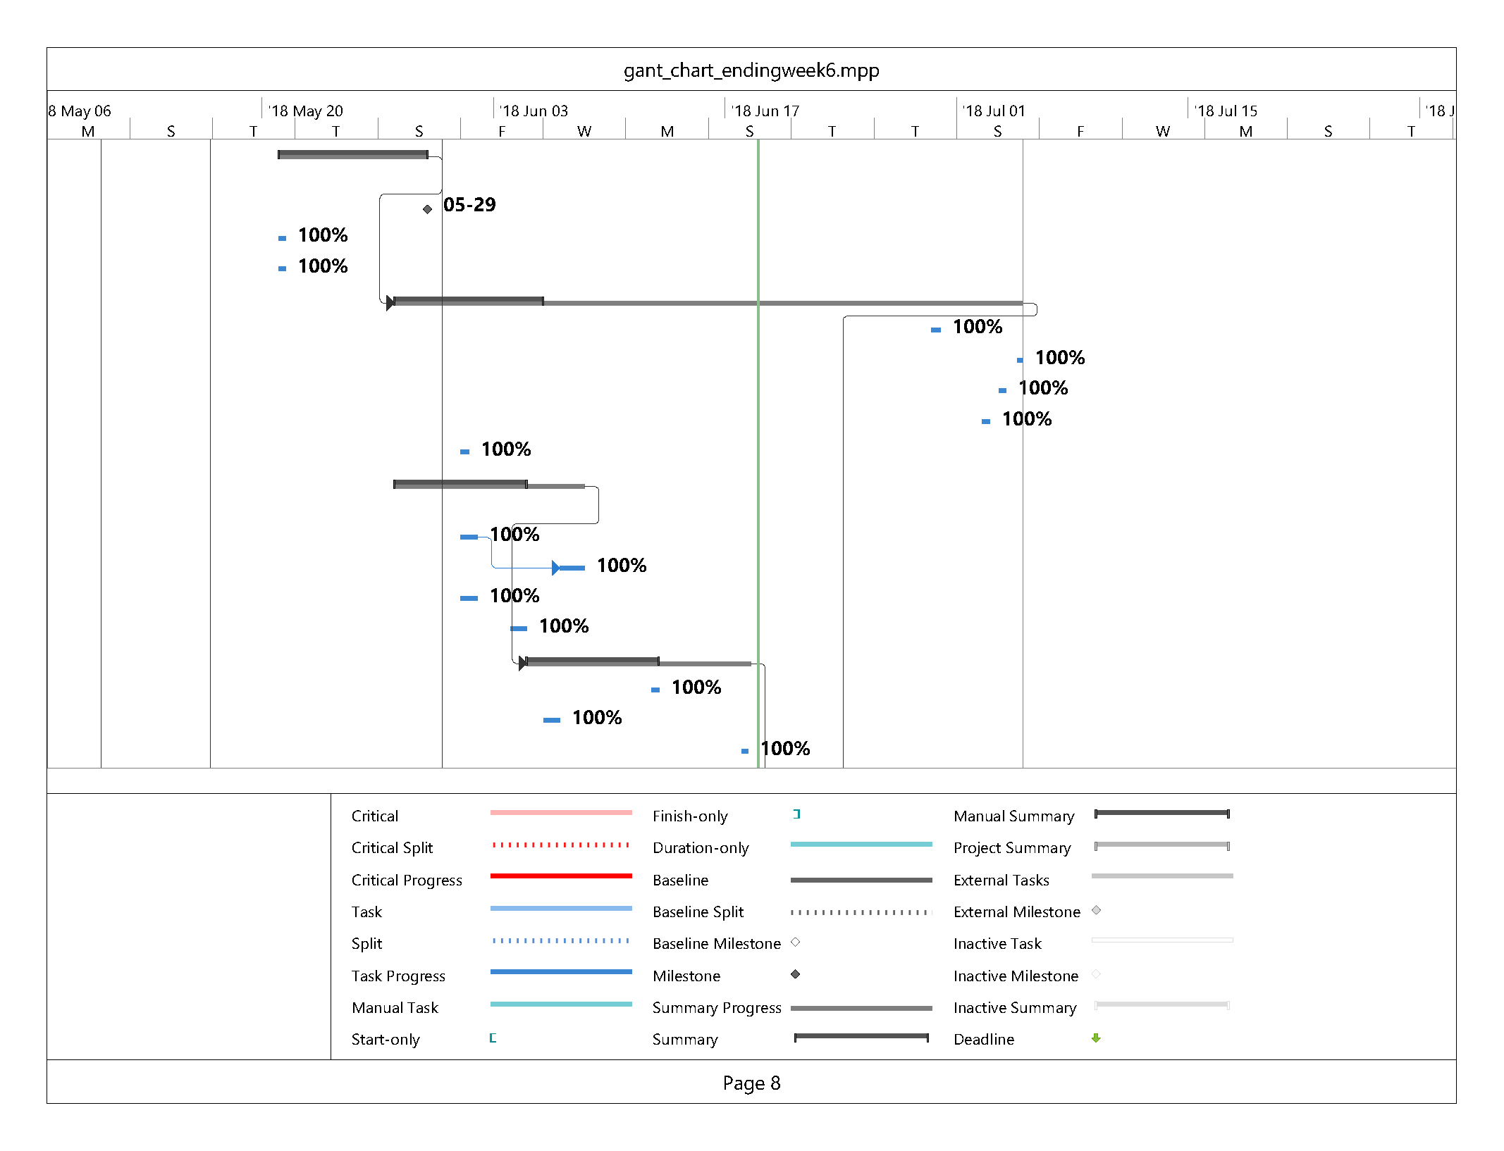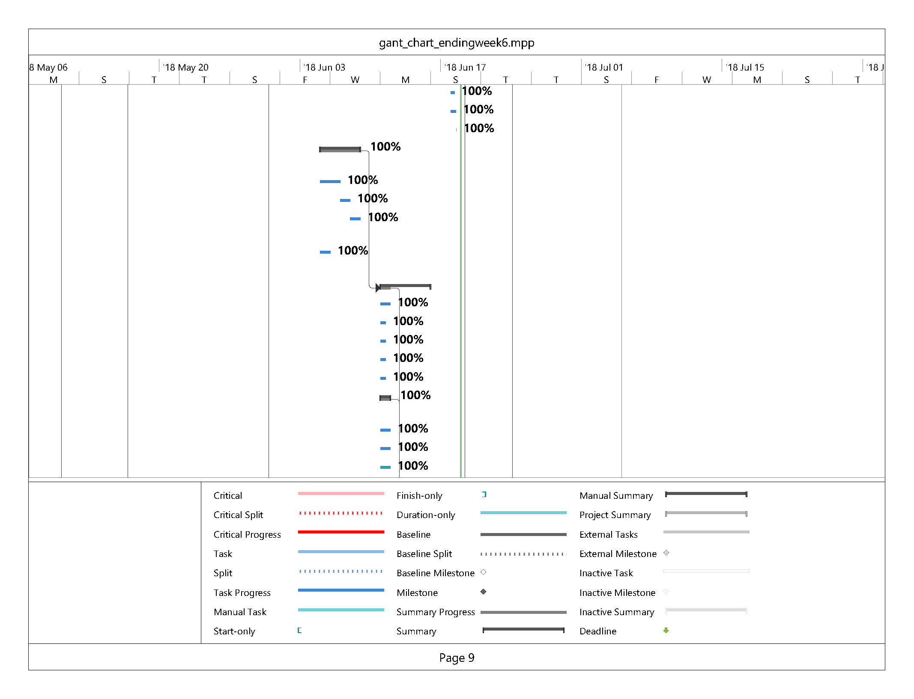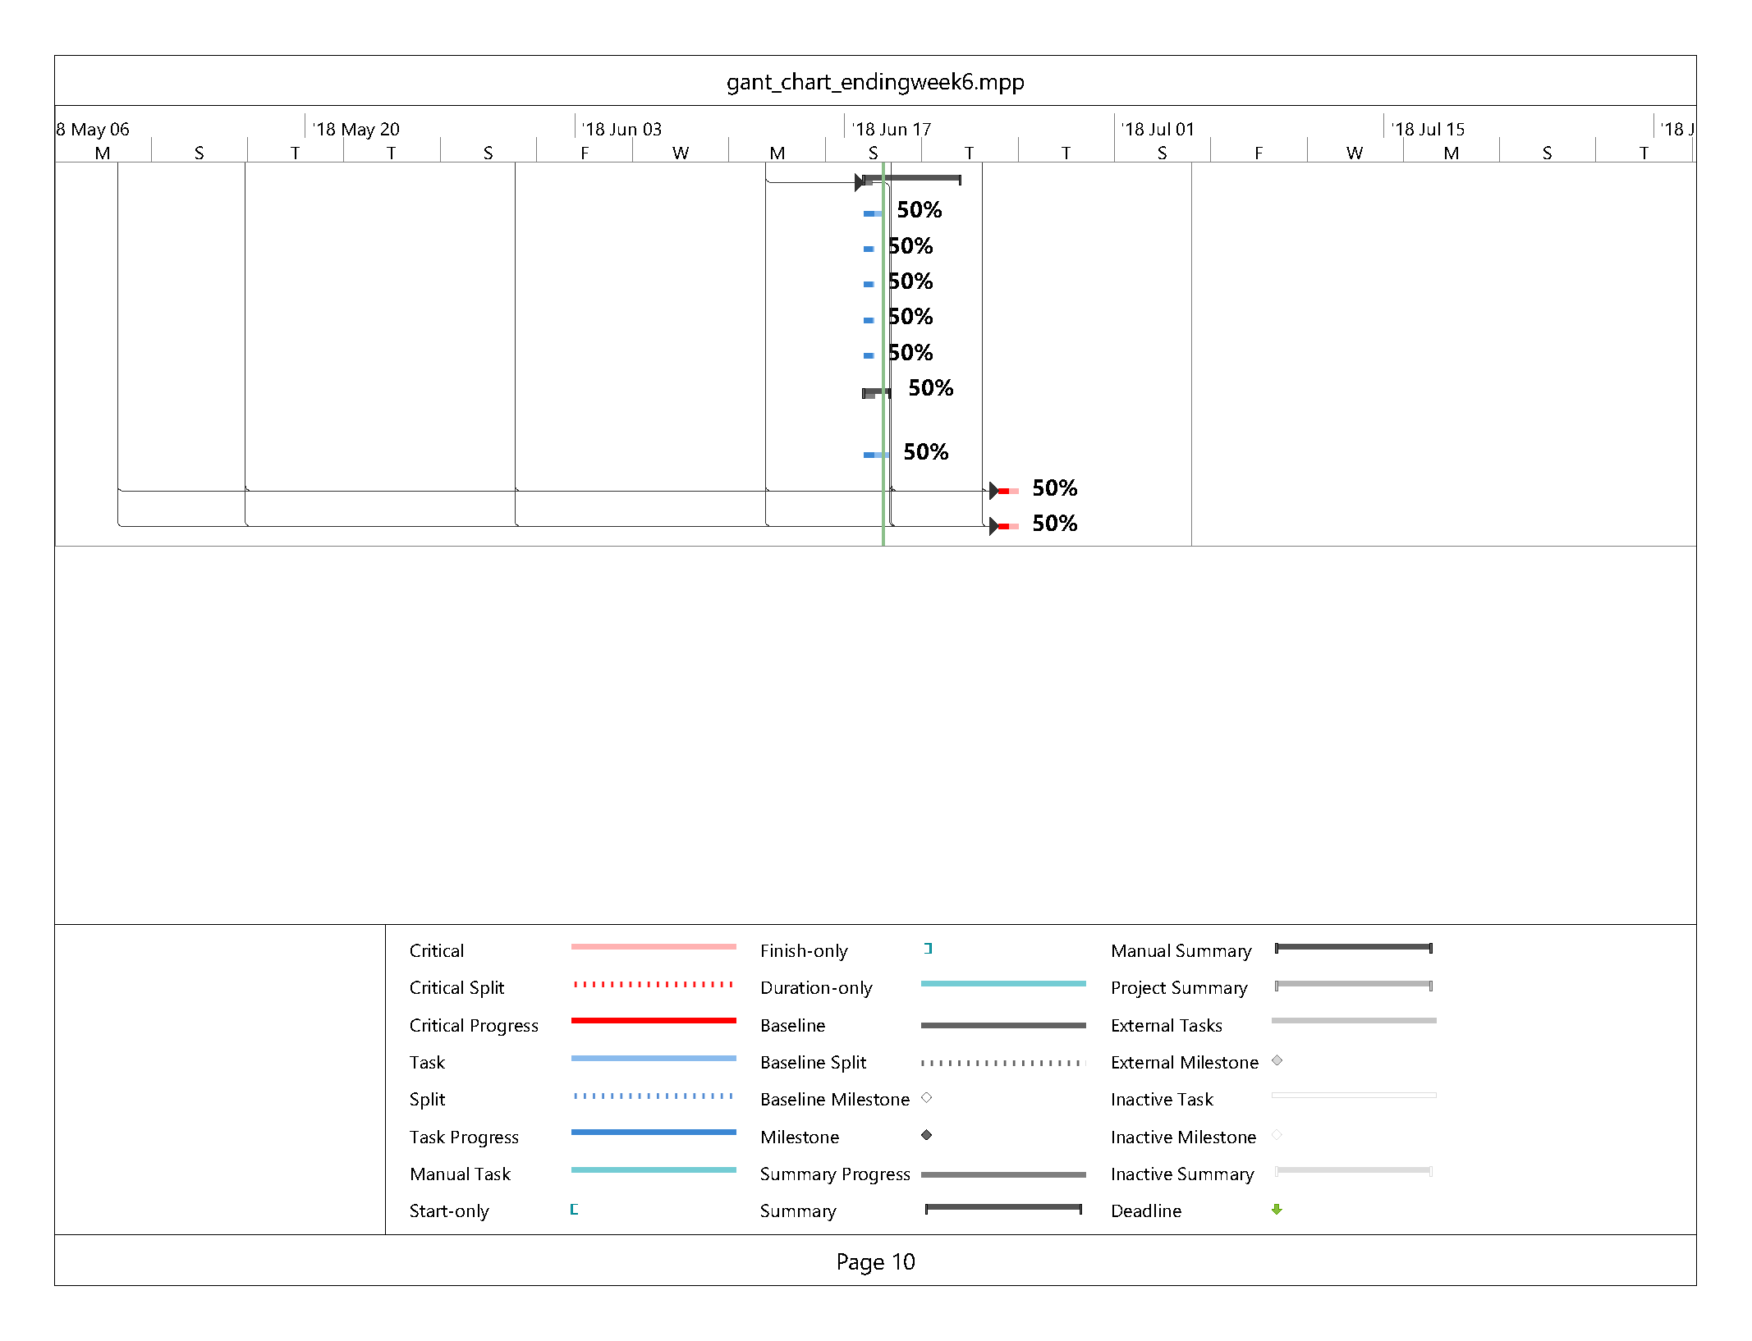

|  |
| --- |
| **Git Log** |

Jacob Warnes:Merge branch 'master' of https://gitlab.camosun.bc.ca/ics199-2018/group07/website-development-build

Isaac Thiessen:now prints reciepts

Isaac Thiessen:Updated header with proper title

Isaac Thiessen:Merged products and search page

Isaac Thiessen:fixed cart bug

jwarnes:added empty cart case and email sent to stripe

jwarnes:Redericts to account.php after payment is processed and added some $ to account.php total

jwarnes:fixed up the account page displaying the wrong total

Brendon Waters:Stripe now implements clear cart and generate receipt. Fully implemented now.

Brendon Waters:Merge branch 'master' of https://gitlab.camosun.bc.ca/ics199-2018/group07/website-development-build

Brendon Waters:Implemented Stripe functionality; passes correct value from cart now.

Isaac Thiessen:Added reciept printing function

Isaac Thiessen:Merge branch 'master' of https://gitlab.camosun.bc.ca/ics199-2018/group07/website-development-build

Isaac Thiessen:fixed spelling mistake that broke queries

Brendon Waters:Amended account history query to correct spelling of receipt and amended DB to match.

Isaac Thiessen:added a decimal place in sub totals in both cart and place order page

Isaac Thiessen:added more foramtting to order summary page

jwarnes:function updated with new log out

jwarnes:Improved logout functionality

Brendon Waters:Added Stripe functionality that adds dummy transaction only; requires you to install Composer on your Deepblue and use it to install the Stripe php library or it won't run.

Brendon Waters:Merge branch 'master' of https://gitlab.camosun.bc.ca/ics199-2018/group07/website-development-build

Brendon Waters:Incremental progress on order summary before purchase.

Isaac Thiessen:Merge branch 'master' of https://gitlab.camosun.bc.ca/ics199-2018/group07/website-development-build

Isaac Thiessen:Added order history in accounts page, as well as accountpage and appropriate links

Jacob Warnes:Merge branch 'master' of https://gitlab.camosun.bc.ca/ics199-2018/group07/website-development-build

jwarnes:Merge branch 'master' of https://gitlab.camosun.bc.ca/ics199-2018/group07/website-development-build

jwarnes:upadted weekly task

Jacob Warnes:team lead docs to be submitted